

Name: Laiba Faisal

Reg id: 213002

Class: BSCS-B

PF ASSIGNMNET # 3

Submitted to: Sir Yasir

**QUESTION 1:**

**CODE:**

//213002_Laiba Faisal

#include<iostream>

#include<fstream>

using namespace std;

int addition (int,int);

int subtraction(int, int);

int multiplication(int, int);

double division(int,int);

int mod(int,int);

int main()

{

int a,b;

cout<<"Welcome!"<<endl;

char option;

ofstream output;

output.open("Calculator.txt");

do{

cout<<"Please select either of the following options: "<<endl;

cout<<"1 - Addition"<<endl

<<"2 - Subtraction"<<endl

<<"3 - Multiplication"<<endl

<<"4 - Mod"<<endl

<<"5 - Division"<<endl

<<"E - Exit"<<endl

<<"Enter your choice: "<<endl;

cin>>option;

switch(option)

{

case '1':

{

cout<<"Enter first integer: ";

cin>>a;

cout<<"Enter second integer: ";

cin>>b;

system("cls");

cout<<"The sum of "<<a<<" and "<<b<<" is: "<<addition(a,b)<<endl;

output<<a<<" + "<<b<<" = "<<addition(a,b)<<endl;

break;

}

case '2':

{

cout<<"Enter first integer: ";

cin>>a;

cout<<"Enter second integer: ";

cin>>b;

cout<<"Difference between the two numbers is: "<<subtraction(a,b)<<endl;

output<<a<<" - "<<b<<" = "<<subtraction(a,b)<<endl;

break;

}

case '3':

{

cout<<"Enter first integer: ";

cin>>a;

cout<<"Enter second integer: ";

cin>>b;

cout<<"Product of the two numbers is: "<<multiplication(a,b)<<endl;

output<<a<<" * "<<b<<" = "<<multiplication(a,b)<<endl;

break;

}

case '4':

{

cout<<"Enter first integer: ";

cin>>a;

cout<<"Enter second integer: ";

cin>>b;

cout<<"Remainder of "<<a<<"/"<<b<<" is: "<<mod(a,b)<<endl;

output<<"Remainder of "<<a<<" / "<<b<<" = "<<mod(a,b)<<endl;

break;

}

case '5':

{

cout<<"Enter first integer: ";

cin>>a;

cout<<"Enter second integer: ";

cin>>b;

cout<<a<<" divided by "<<b<<" is: "<<division(b,a)<<endl;

output<<a<<" / "<<b<<" = "<<division(b,a)<<endl;

break;

}

case 'E':

{

cout<<"Thanks for using this program!"<<endl

<<"Have a good day!"<<endl

<<"Bye!"<<endl;

break;

}

default:

{

cout<<"Sorry! Invalid entry!"

<<"Bye!"<<endl;

}

}//switch

}//do bracket

while (option!='E');

return 0;

}

//FUNCTIONS:

int addition(int x, int y)

{

return x+y;

}

int subtraction(int x, int y)

{

return x-y;

}

double division(int x, int y)

{

return static_cast<double>(y)/x;

}

int multiplication(int x, int y)

{

return x*y;

}

int mod(int x, int y)

{

return x%y;

}

**EXECUTION SCREENSHOTS:**

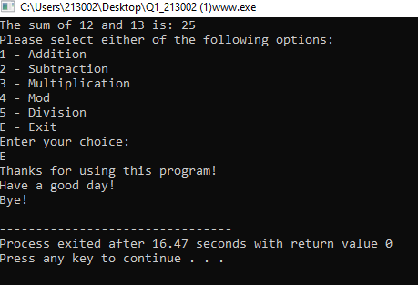

**QUESTION 2:**

**CODE:**

//213002_Laiba Faisal

#include<iostream>

#include<cstring>

using namespace std;

bool authentication(string,string);

int main()

{

bool access;

string name;

string pw;

cout<<"\t\t\t\tWelcome to login page "<<endl;

cout<<"Username: "<<endl;

getline(cin,name);

cout<<"Password: "<<endl;

getline(cin,pw);

access = authentication(name,pw);

if (access==true)

{

cout<<"Access granted!"<<endl;

}

else if (access==false)

{

cout<<"Access denied!"<<endl;

}

}

bool authentication(string x,string y)

{

if (y.length()>=6)

{

for (int i =0; i<=x.length(); i++)

{

islower(x[i]);

if (!(islower(x[i])))

return false;

else

return true;

}

}

}

**EXECUTION SCREENSHOT:**

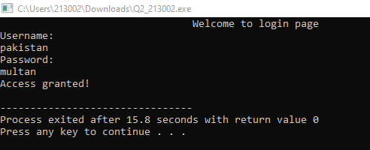

**QUESTION 3:**

**CODE:**

//213002_Laiba Faisal

#include<iostream>

#include<cstdlib>

using namespace std;

int computer()

{

return rand()%3+1;

}

bool winner(int a,int b)

{

if (a==1 && b==3)

{

return true;

}

else if (a==3 && b==2)

{

return true;

}

else if(a==2 && b==1)

{

return true;

}

else

{

return false;

}

}

bool decider(bool w)

{

if (w==true)

{

cout<<"Congratulations! You won the game!"<<endl;

}

**else**

**{**

**cout<<"Oops!You lost the game!\nBetter luck next time!"<<endl;**

**}**

**}**

int game()

{

int player;

bool win=false;

cout<<"\t\t\t\tgamegames.com"<<endl

<<"Hey there! Let's play rock, paper and scissors!"<<endl

<<"Make a choice:"<<endl

<<"1\tRock"<<endl

<<"2\tPaper"<<e"<<ndl

<<"3\tScissorsendl;

cin>>player;

cout<<"You chose: "<<player<<endl

<<"Now it's computer's turn."<<endl

<<"Computer's choice: "<<computer()<<endl;

return player,computer();

}

bool check(int a,int b)

{

if (a==b)

{

return true;

}

else

return false;

}

int main()

{

int player,x;

bool win=false;

bool ch=false;

game();

ch=check (player,x);

if (ch==true)

{

while(ch==true)

{

game();

ch;

}

win=winner(player,computer());

decider(win);

}

else

{

win=winner(player,computer());

decider(win);

}

}

**EXECUTION SCREENSHOT:**

